Benchmarking local network topology of sustainable heat supply: An open-source approach downscaling integrated assessment model results

* Nature Energy (no experience ;))
* Wiley: WIREs Climate Change, WIREs Energy and Environment
* Elsevier: Sustainable Cities and Society, Renewable Energy, Energy Policy

Inhalt

1. Introduction 2

2. State of the Art 3

2.1 Downscaling challenges for mapping global decarbonization pathways on higher disaggregation levels 3

2.2 Implications of disaggregated global results on local energy system and sustainable energy demand provision 3

2.3 Assessing and evaluating centralized and network-based sustainable energy supply 3

3. Methodology 4

3.1 Algorithm 1: Sequential downscaling of heat generation per technology from the region/country to the sub-region level accounting for infrastructure requirements 4

3.2 Algorithm 2: Iterative downscaling of heat generation per technology from the sub-region to the small sub-region level using iterative indicator-based benchmarking 5

3.3 Case study, scenario definition, and empirical settings 5

3.3.1 An Austrian case study obtained from the H2020 project openENTRANCE 5

3.3.2 Definition of the deep decarbonization scenarios 5

3.3.3 Empirical settings 5

3.3.4 Open-source environment and availability 5

4. Results 6

4.1 Decarbonized low temperature heat supply on the country, sub-region, and small sub-region level 6

4.2 Implications of deep decarbonization pathways on Austrian sub-regions with high potentials of centralized low temperature heat supply 7

4.3 Low temperature heat network topology on the small sub-region level 9

4.4 Comparing existing and future projections of low temperature heat networks using heat and population density as criteria 9

4.5 Embedding existing infrastructure into future projections? (nexte paper ;)) 9

5. Conclusions and outlook 10

6. Appendix 10

# Introduction

**Integrated assessment models**

* **Form a prime tool to inform about climate change mitigation**
* **Differences in model projections**
* **Indicators as a community standard, to systematically and routinely assess**
* **Widely used for climate policy and climate change analysis**
* **Long term policy goals and near-term policy choices**
* **Cross-sectoral and, cross-regional system interactions (energy, land, economy, climate)**
* **Key information source for climate change mitigation policy process IPCC assessment reports**

**Within IAMs, cost-benefit detailed process IAMs (explore different pathways to reach selected policy goals) – different functional structures.**

**Structure and assumptions affect results**

***As such,***

***In fact,***

***Stylized***

1. ***… and (b)***

***Aim to cover the second, where possible.***

***A subsequent function, but beyond the limits of this study, is to qualify the model behavior.***

***Modeling disciplines.***

***Evaluate their performance.***

***Qualify their behavior***

# State of the Art

## Downscaling challenges for mapping global decarbonization pathways on higher disaggregation levels

* Integrated assessment model help us to better understand complex relations
* In general, different fields and sectors
* Temporal and spatial downscaling
* Focusing on the energy sector

## Implications of disaggregated global results on local energy system and sustainable energy demand provision

* Implications of different IAM results on local energy

## Assessing and evaluating centralized and network-based sustainable energy supply

# Methodology

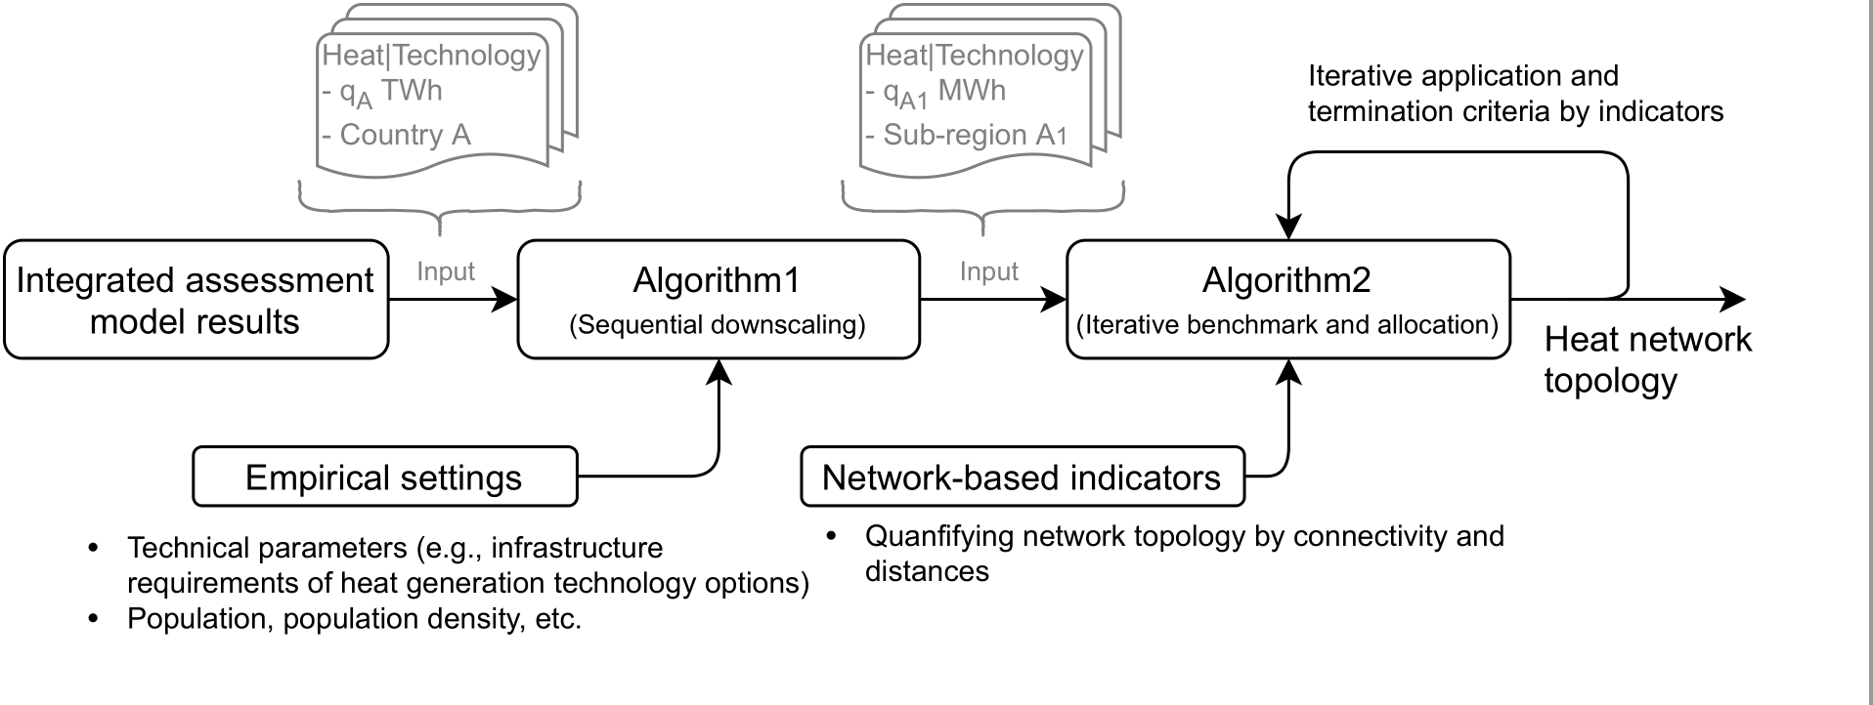

## Algorithm 1: Sequential downscaling of heat generation per technology from the region/country to the sub-region level accounting for infrastructure requirements

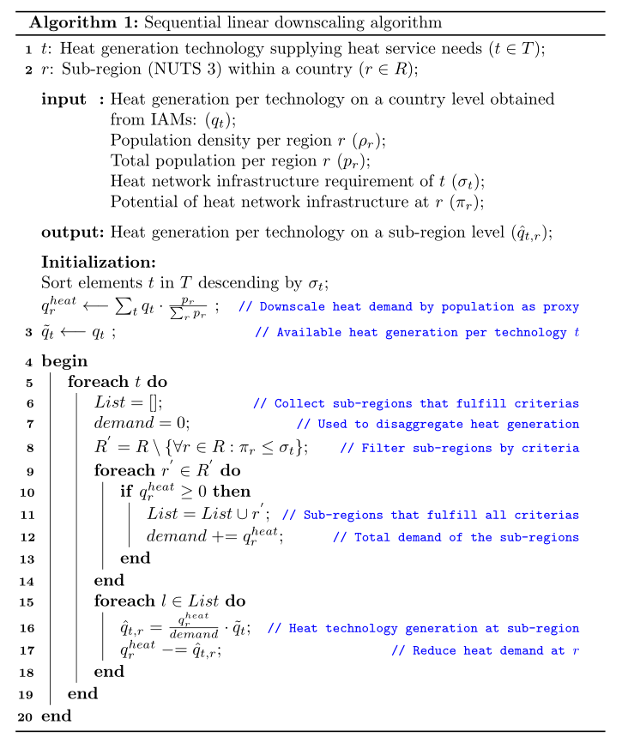

## Algorithm 2: Iterative downscaling of heat generation per technology from the sub-region to the small sub-region level using iterative indicator-based benchmarking

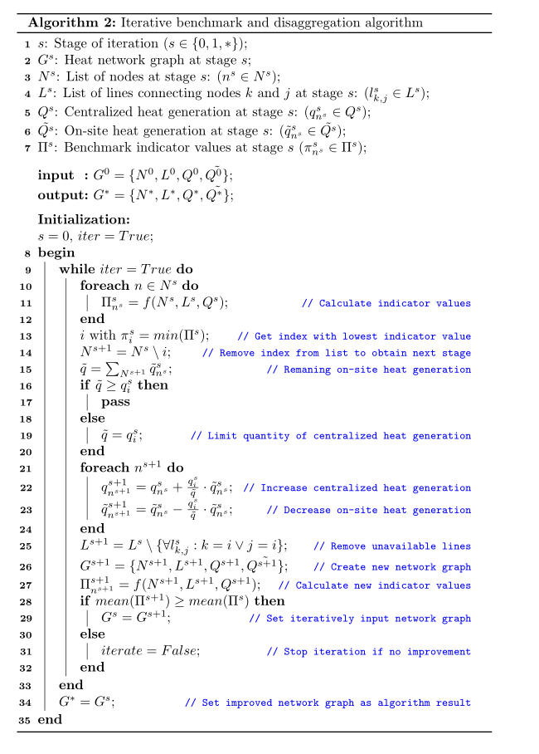

## Case study, scenario definition, and empirical settings

### An Austrian case study obtained from the H2020 project openENTRANCE

### Definition of the deep decarbonization scenarios

### Empirical settings

### Open-source environment and availability

# Results

## Decarbonized low temperature heat supply on the country, sub-region, and small sub-region level

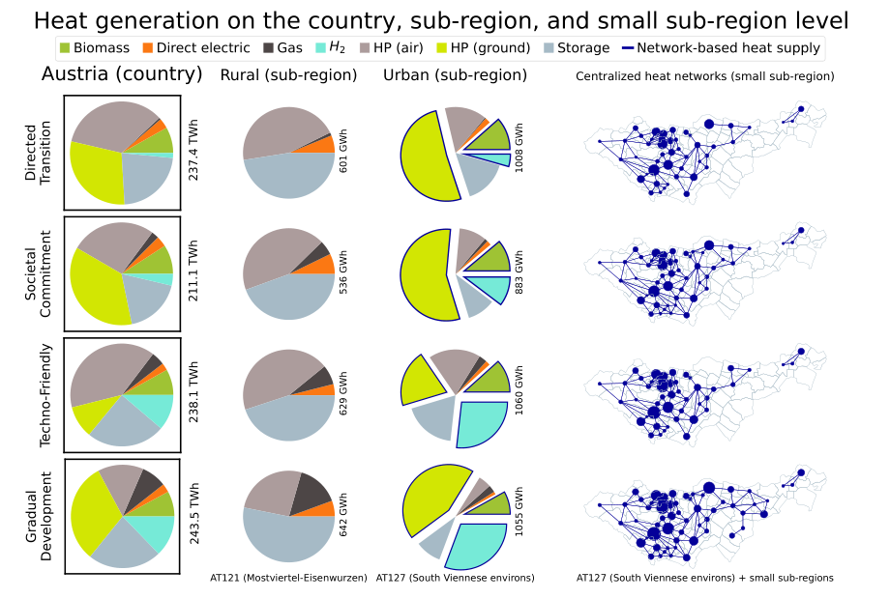

## Implications of deep decarbonization pathways on Austrian sub-regions with high potentials of centralized low temperature heat supply

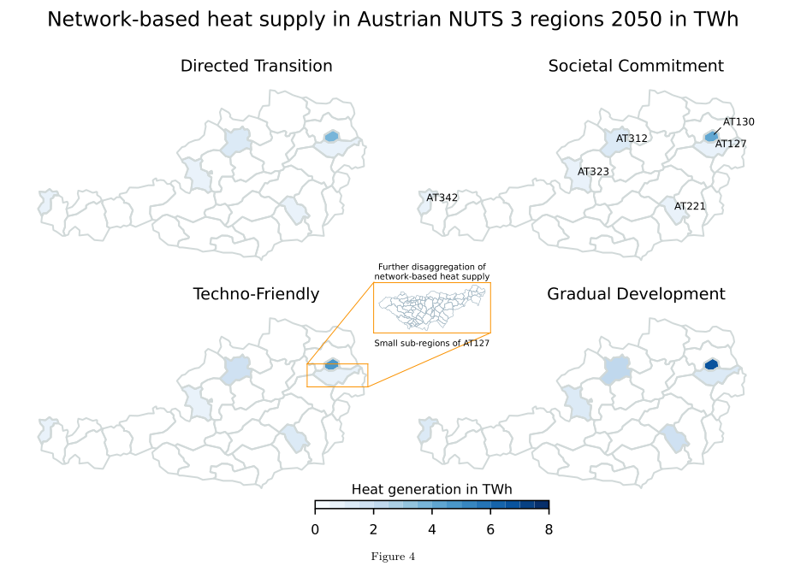

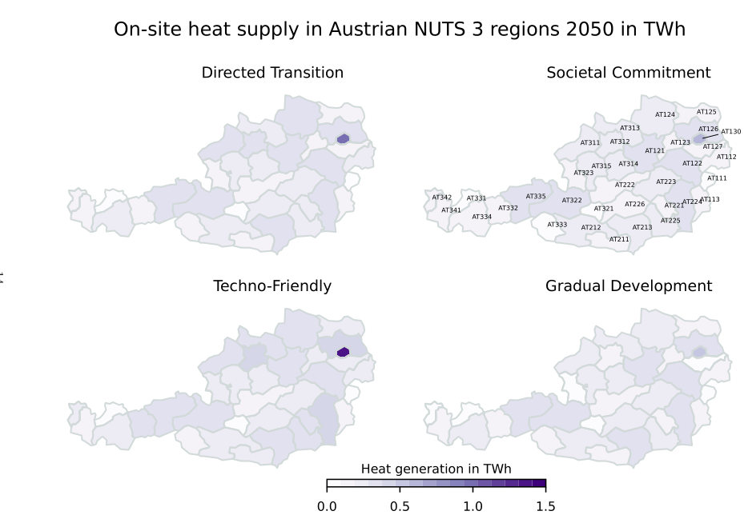

## Low temperature heat network topology on the small sub-region level

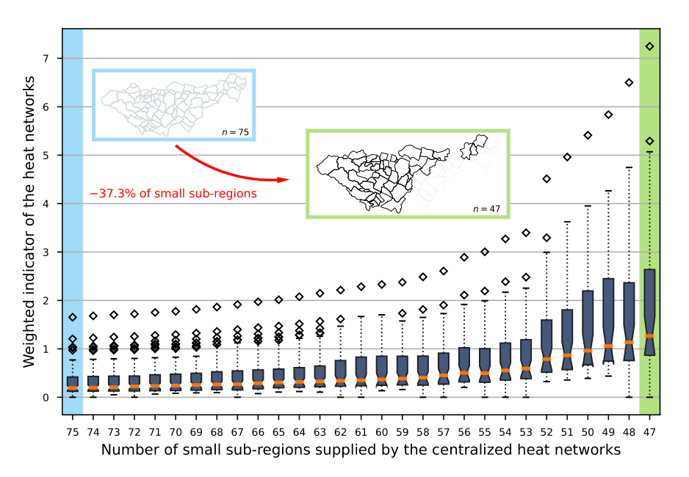

## Comparing existing and future projections of low temperature heat networks using heat and population density as criteria

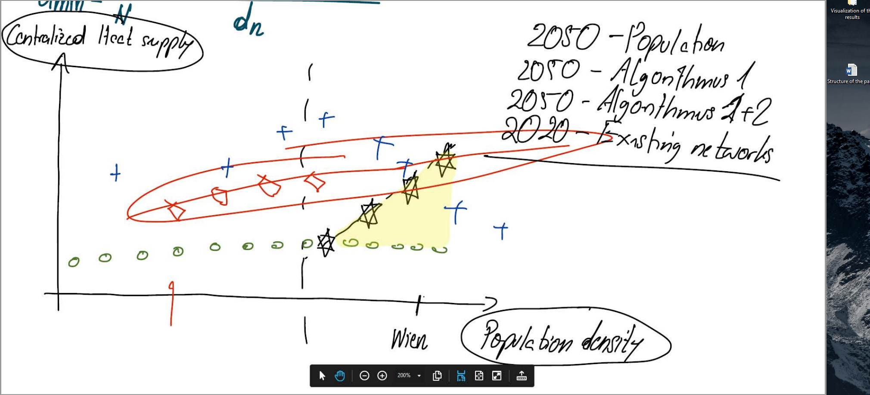

## Embedding existing infrastructure into future projections? (nexte paper ;))

# Conclusions and outlook

# Appendix